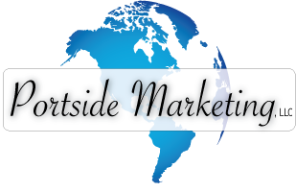

Dear Business Owner:
Congratulations on your new business! We know what an exciting, fun time this is for you and your new business. We also know small business and your next step may likely be getting your business identity established and creating your initial marketing materials. We’d love to help you!
We’d like to introduce ourselves. We are Portside Marketing, LLC, a successful local marketing company that has worked with hundreds of businesses, establishing brand identities and new marketing materials that are both effective and attractive. Our award-winning staff has over 25 years of experience and a proven track record, working with small to medium-sized businesses.
We offer a full compliment of design and printing services, along with marketing expertise, to help you grow your business:

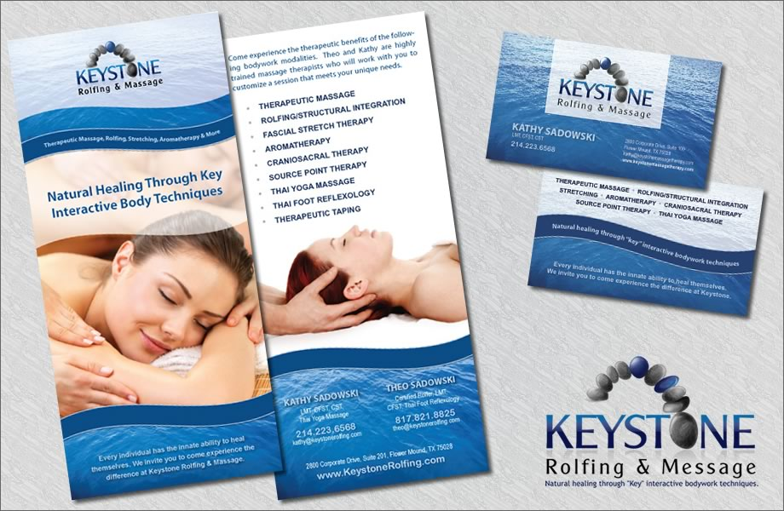
- Business Cards, Letterheads & Envelopes
- Marketing Materials & Ad Layout
- Logo & Brand Identity Creation
- Brochures, Flyers & Postcards
- Online Marketing & SEO
- Website Design & Ecommerce
- Google Local / Maps Listings

Please call for a free, no obligation telephone consultation. If we both think there is a good fit, we can talk further about your brand and marketing needs. We’ll even extend to you a complimentary market analysis. Why? Because we don’t expect you to just give us your business - we intend to earn it! Give us a call today at 972. 979.9316.
Sincerely,

Lisa Parziale
Co-founder
Portside Marketing, LLC

We award-winning designers amd marketing experts who have tested and refined our design process to create marketing materials that garner the best response rates and customer actions. Here is a list of just some of the items we can create for your new business.
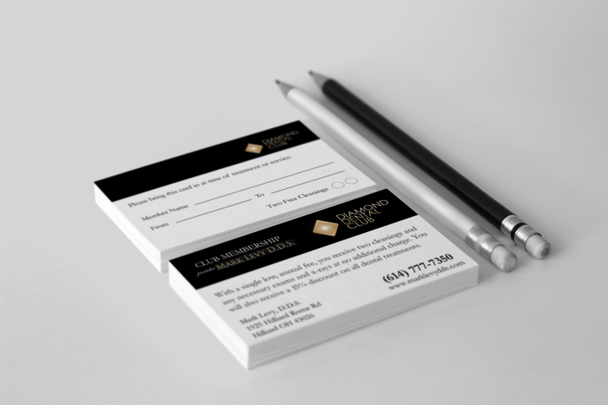
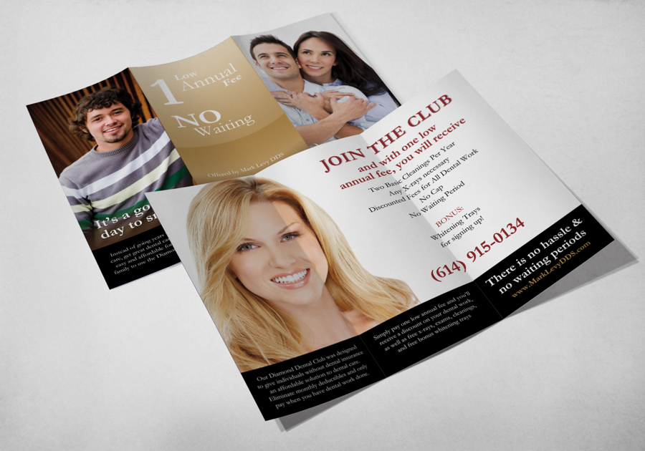
- Business Cards
- Letterhead & Envelopes
- Brochures, Flyers & Tri-folds
- Rack Cards & Postcards
- Menu design and printing
- Welcome letters (like this) to new businesses, product and service flyers & page inserts
- Book-style brochures, book layout and corporate documents

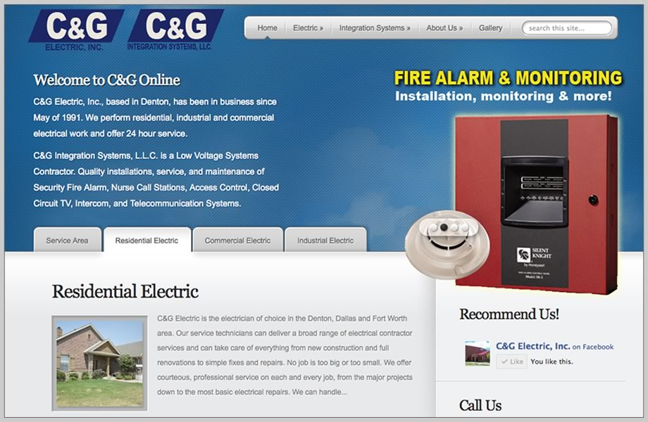
Business Identity Package – Only $595
Our Business Identity Package includes everything you need for your new business identity to look professional and sharp. This package includes custom design, printing and shipping (tax not included – only applicable to Texas residents).
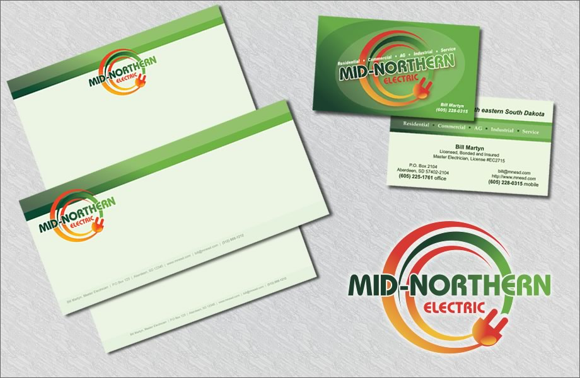
You will receive:
- 1000 Business Cards (14pt gloss or 16pt matte)
- 500 Sheets of Letterhead (color front only)
- 250 #10 Envelopes (color front only)
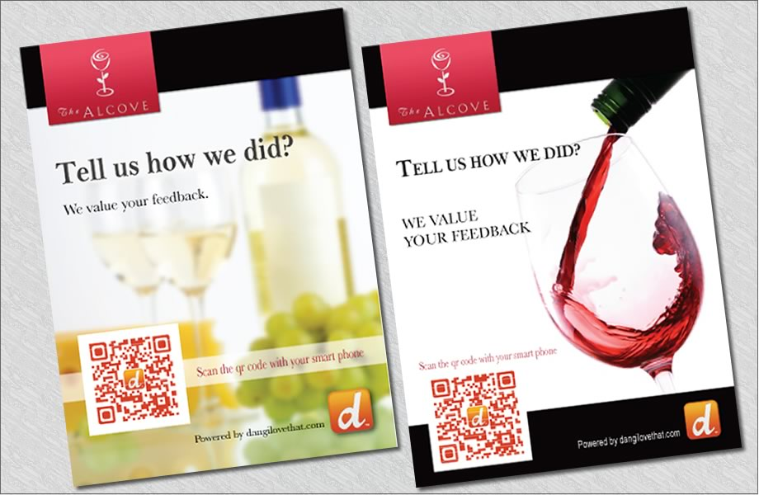
- Shipping & Design Included!
- Add a logo design package for only $195
- Add 500 Tri-fold brochures for $215
See more of our award-winning designs at
www.PortsideMarketing.com

