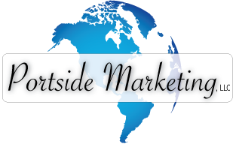

Dear Business Owner:
Congratulations on your new business! As a new business owner, there are a few key things you may need in order to get going and start reaching your target market. Portside Marketing specializes in helping new businesses build their brand and create an online presence. We have business packages and services that are geared for new businesses that are affordable and effective. Our team has over 20 years experience in traditional and online marketing, building websites, print advertising and marketing, and creating effective marketing campaigns.
Here is a list of just some of the services that we offer to help you grow your business:

BUSINESS IDENTITY
Logo / Brand Creation – $195
Business Cards / Letterhead
Marketing Materials / Ad Layout
Brochures / Flyers / Post Cards

ONLINE MARKETING
Complete Websites - $1495
Social Media (Facebook, LinkedIn, Twitter)
SEO Page One (Google, Bing, Yahoo)
Google Local / Maps listing

Please call for a free, no obligation consultation. We will perform a free market analysis and discuss your business goals. Understanding your market is key to creating an effective marketing strategy that delivers results (or what we like to call profit). Then, we can help you decide what best serves your needs. The market analysis is yours to keep, even if you do not choose to use our services.
We don’t expect you to just give us your business - we intend to earn it! Give us a call today at 972. 979.9316 to discuss your new business needs. ALL new customers receive 15% off all services on their first order – mention the new customer PROMO 512 deal!
Sincerely,

Lisa Parziale
Co-founder
Portside Marketing, LLC
www.PortsideMarketing.com
Check out our online portfolio and learn more about us.

NEW CUSTOMERS RECEIVE 15% OFF JUST BY MENTIONING THIS FLYER

Design & Full Color Print Services

- Brochure, poster, folder or menu design and printing
- Welcome letters (like this) to new businesses, product and service flyers & page inserts
- Business cards, letterhead and envelopes
- Rack cards, print brochures, book layout and corporate documents

Online Marketing & Social Media

- Websites, blogs, shopping carts and online newsletters / email marketing
- List building (getting you a list of qualified customers to market to)
- Google Page One ranking – getting you on page one of Google, Bing or Yahoo
- Google Maps entry – ensuring you are listed / optimized for local searches (Google Places)
- Facebook Business Pages – create / design custom Facebook landing pages and tabs
- Twitter Landing Pages – spice up your Twitter backgrounds
- Social Media campaigns – tweeting, posting, blogging and more
- Surveys – custom surveys and feedback from your customers

Call us TODAY and we will talk to you about your business, what your marketing needs may be and how we can assist. We offer FREE consultations, no obligation or HIGH PRESSURE SALES.
We earn your business at a fair price and keep it with exceptional service!
CALL TODAY 972.979.9316
New Customers GET 15% OFF
We know what it is like to be a new business. So we would like to offer you a 15% NEW BUSINESS DISCOUNT on any products or services you purchase, just for allowing us a chance to earn your business. That is a huge discount you will not see anywhere else. If one of the packages below do not suit your needs, give us a call and we will be happy to create a custom package.

Business Identity Package – Only $635 (add logo design for $150)
- We will design your business identity start-up pieces and have them printed and delivered to you for only $635. That is over 15% off our regular prices. All printing is color, 2-sided UV coated glossy on 14pt paper. This package includes custom designs and professional photos.
This includes CUSTOM designs, not just the printing. Compare that to anyone, we think you will see how valuable this is.
Go to our website to see samples!
www.PortsideMarketing.com
  - 1000 Business Cards (glossy, 2-sided)
  - 1000 4x9 Rack Cards (glossy, 2-sided)
  - 1000 Post Cards (glossy, 2-sided)
  - Shipping & Design Included!
Small Business Website – Only $1275 (add Facebook page for $125)
- We will design a website so you stand apart from your competitors AND we get you started on basic Search Engine Optimization (SEO) by making sure your content is optimized for getting ranked in Google, Bing, Yahoo and more. Your are saving $250 PLUS free hosting!
  - All content pages (standard pages - static products, about us, etc. – includes stock images)
  - Contact form that sends information to your email (or multiple emails)
  - Locations(s) page with Google Map embedded, contact info and directions
  - FREE 1-Year Hosting!

Here are just a few samples of logo design, business identity design and websites. For many more, please visit our website: www.PortsideMarketing.com

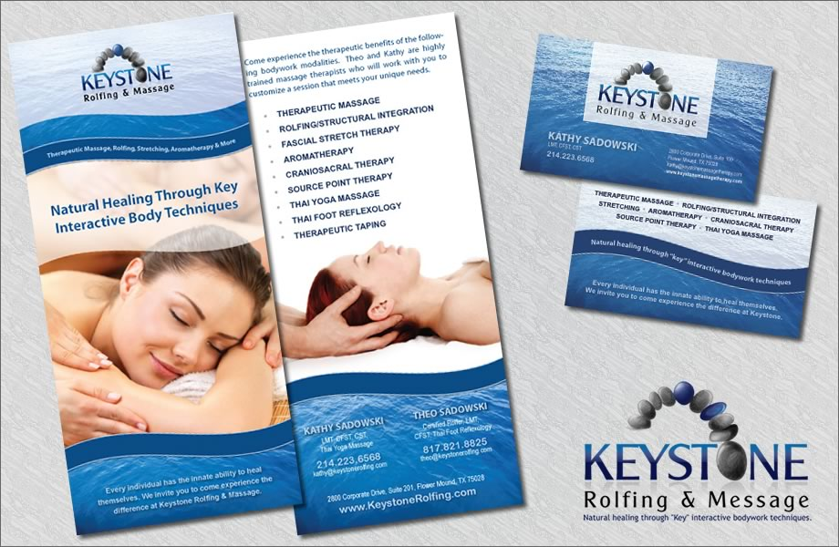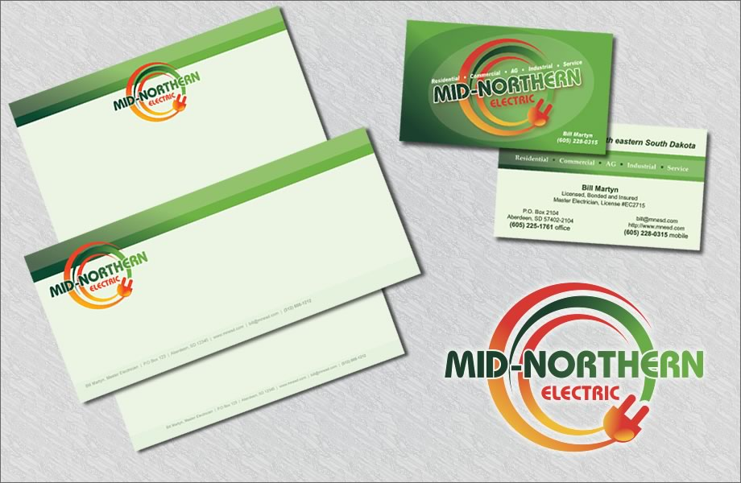
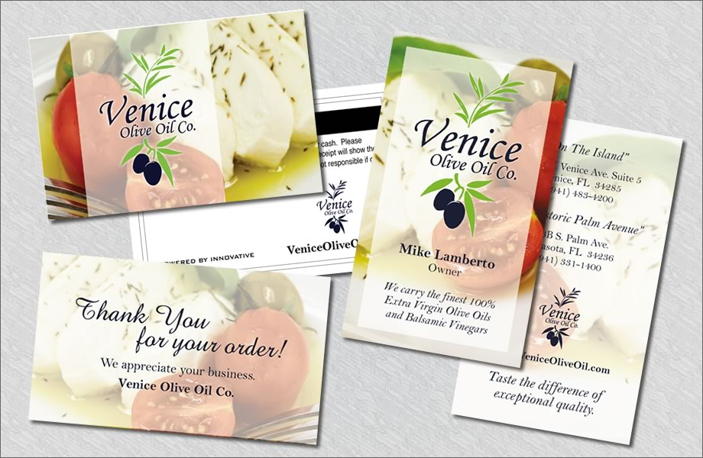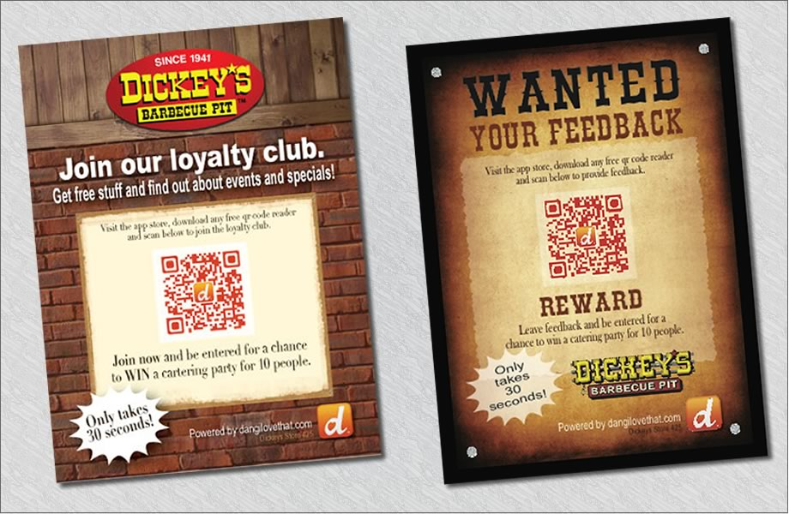
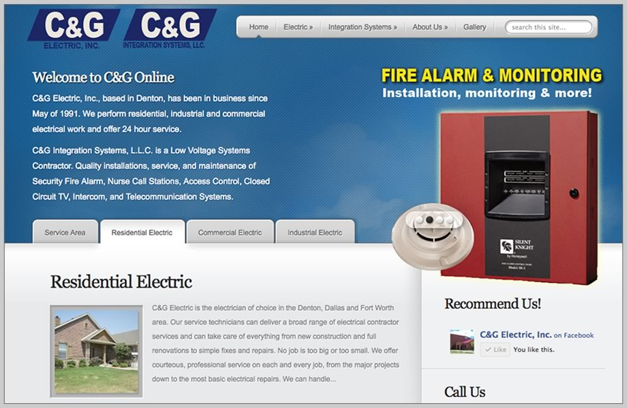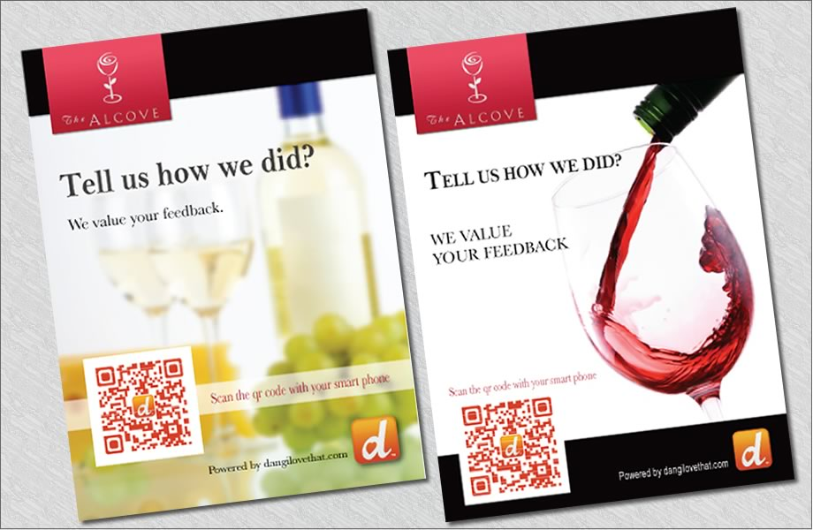
Our design team creates award winning logos, business pieces and websites!

